Start Sheet for the

Northampton & District Cycling Association

10 mile Time Trial (TT Series Event 1 of 8)

Sunday 7th of May 2023 starting at 07:00 | FOUNDED 1935
 | PRESIDENT:
Promoted for and on behalf of Cycling Time Trials under their Rules and Regulations | Sue Holliday
This event is a counting event for all categories of the N&DCA Time Trial Series Championships and is organised on behalf of the N & DCA by 45 Road Club and its Members.)

For the latest points tables visit the results website: http://www.northamptondca.org.uk/

Headquarters:

Glebe Farm, 132 Doddington Rd, Earls Barton, Northampton NN6 0NS

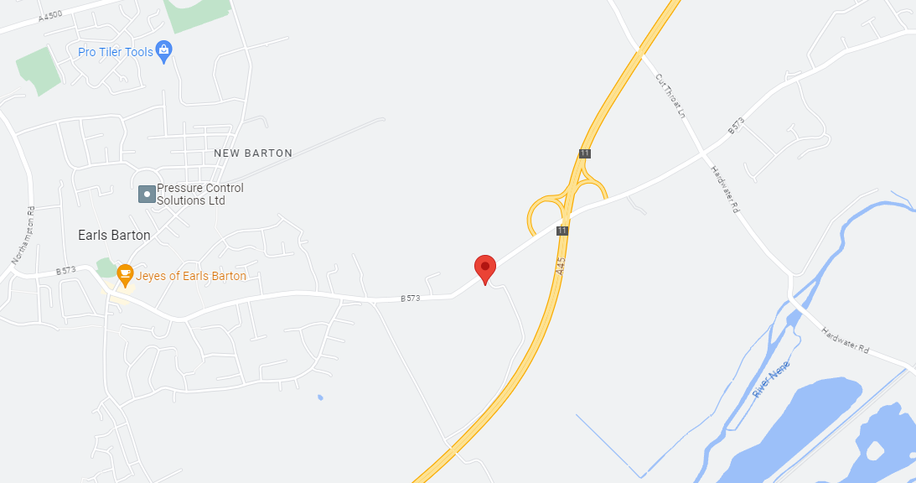

Facilities:

The HQ will be open from just after 06:00 for toilets and car parking.

Timekeepers: Mike Smith and Stuart Ross These are competent club timekeepers.

Event Secretary: Neil Barford, 22 Southfield Road, Northampton, NN5 6HN . Mob: 07913112007

Prize  Values | Handicap Prize
1st | £15
2nd | £12
3rd | £10
4th | £ 8
5th | £ 5

Please note that:
The handicap prize for this event is based on best improvement against predicted Spindata times. In the event of no Spindata prediction being generated which might be the case if not many events have been ridden recently, the time to beat will be the rider’s PB for 10 miles as supplied by the CTT entry form data. To be eligible for this prize competitors must have a 10 mile best time to beat.

Local Regulations:

NO U-TURNS are allowed within sight of either the start or the finishing points. Riders carrying out this dangerous manoeuvre are liable for DISQUALIFICATION from the event and further disciplinary action by the district committee.

Please also remember that there is a need for good behaviour and consideration towards other road users and local residents in order to avoid any complaints being received.

Numbers:

These will be available at the Event Headquarters, not at the Start. Each number will have pins in each corner, please remove and place in box if not needed because you are using a NoPinz pocket. Also only use the corner pin holes and do not make more holes if using pins. Please ensure that the body number is clearly visible from behind and fixed on the lower back.

Signing In/Out:

Please ensure that you sign the “Signing-On” Sheet when collecting your number and clearly call out your number when crossing the finish line. Please ensure you return your number to HQ and sign-out, using the “Signing-on/off” Sheet. Failure to do so could result in your exclusion from the Results.

Road Bike category

For your ride in this event to be eligible for the season long Road Bike category please indicate this on the signing on sheet by ticking the appropriate box or writing RB next to your name. The start line assistant will check your bike meets the road bike criteria at the same time as checking lights. To be eligible your bike must not have “tri-bars” or equivalent, disc wheels, less than 12 spokes or other fairings. In event of a dispute regarding RB eligibility, the organisers decision is final.

Compulsory Front/Rear Lights and Helmets:

Regulation 14(i) requires all Competitors to have affixed to the rear of their machine a working rear red light, either flashing or constant, that is illuminated and in a position that is clearly visible to other road users.
Regulation 14(j) requires all Competitors to have affixed to the front of their machine a working front white light, either flashing or constant, that is illuminated and in a position that is clearly visible to other road users.
Regulation 15 requires that all Competitors must wear a properly affixed helmet which must be of hard/soft shell construction. Helmets should conform to a recognised Standard such as SNELL B95, ANSI Z90.4, AUS/NZS 2063:96, DIN 33-954, CPSC or EN 1078.
Failure of any of the above three points will render the competitor not being allowed to start the event.

Doping Control:

This event may be subject to Doping Control. As soon as you have finished you should return to HQ as it is your responsibility to check if you are required for a Doping Control. Race numbers required for Doping Control will be displayed at the HQ adjacent to the Result Board. If your number is displayed you should report immediately to Doping Control which will be nearby. Remember, it is up to you to check and ensure you comply.

Start Point:

Opposite Glebe Farm, on the B573. Distance 10 bike lengths.

COURSE IDENTIFICATION: COURSE NUMBER N7/10 – NX2-10

START at yellow line west end of concrete bench (facing east towards gt doddington).Proceed 0.23 miles towards Great doddington turn left on to A45 West bound slip road towards Northampton. Exit A45 at the Great Billing slip road (4.06 miles) .Continue round the Great Billing roundabout straight back onto the A45 towards Great doddington.
Exit the A45 at the Great Doddington slip road at 8.1 miles. At the end of the slip road turn left to go over the A45 (For the second time) 8.34 miles. And once again take the left turn onto the A45 westbound towards Great billing 8.55 miles. Head westbound until reaching the Earls Barton slip road at 9.92 miles…..EXIT ONTO SLIP ROAD AND FINISH JUST AROUND SLIGHT BEND TO THE LEFT 10.01 MILES (FINISH LINE IS IN LINE WITH NO STOPPING CLEARWAY SIGN) TIMEKEEPERS ARE BEHIND THE BARRIER ON GRASS VERGE AWAY FROM ROAD AND HAVE GOOD LINE OF SIGHT.

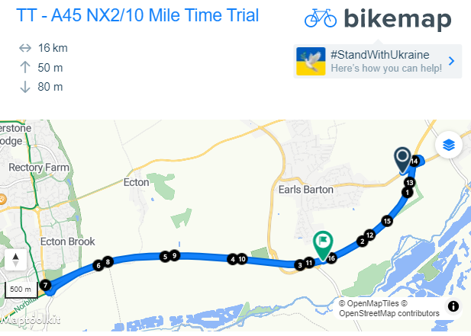
COURSE NOTES:

The only motor vehicles associated with the Event allowed near Start or Finish will be those of the Timekeepers

If passing any Horse Riders, please give due consideration and plenty of space.

Please refrain from warming up on the course after the event has started, as this causes extra work for the timekeepers.

Please keep well into the side, while waiting to start.

You must observe the Highway Code and comply with traffic law and regulations. You must also ride in a manner that is safe for yourselves and all others, and must rely on your own ability and judgement in dealing with hazards, though every effort has been made to marshal the course and the position of ‘Event Aware’ signs, so as to minimise the risk, as required by the Course ‘Risk Assessment’. The onus is still on you the rider, so familiarise yourself with the course details.

The finish line is on a short slip road. Once you have passed the time keepers you MUST TURN LEFT at the junction. Continue down the road and when safe to do so, perform a U-Turn and return to HQ. Any riders gathering at that junction will be DISQUALIFIED. No exceptions.

The course road conditions are very good BUT please be mindful, when passing the Earls Barton turn in, heading eastbound, some of the tarmac is particularly rough for a distance of half a mile.

Competitors:

- = Association Club

Categories: S = Senior W = Woman J = Junior/ Juvenile
Masters Men: A = 50-54, B = 55-59, C = 60-64, D = 65-69, E = 70-74, F = 75 plus
Masters Women: A = 40-44, B = 45-49, C = 50-54, D = 55-59, E = 60-64, F = 65 plus

*NB Masters age category is age on day of first N&DCA event ridden this year.
Juniors/Juveniles:
For the 2023 season there are no separate juvenile or junior sections, only a single U19 category, i.e. Those Competitors aged under 18 or have their 18th birthday during 2022

Result Sheet app:

Subject to availability of sufficiently tech savvy volunteers, we will be trialling the Result Sheet application which will enable you to track times live via the application on your phone if you scan the printed QR code at the Race HQ. Alternatively you can also view the results on screen at the HQ whilst enjoying tea and home made cakes and some lively banter.

Season long competition prizes:

Please note that the actual value of the cash prizes awarded for performance in the various categories will be published after the last event of the season when the total prize fund is known as determined by the surplus generated by the event entry fee income.

Trophies:

Trophies and end of season competition prizes will be awarded at the annual Prize Award Lunch (usually held in January). NB Separate event prizes will be awarded after the last event in the series, not after each event.

The Association’s 12-hour trophies will be awarded to members of Association Clubs for their performances in any open 12-hour event held under CTT Rules & Regulations. The Association’s Long Distance BAR will be awarded to the highest placed rider of an Association Club in the National BBAR. Qualifying events are marked B in the CTT Handbook

For more information on the season long competitions and N&DCA trophies, including past winners, please refer to our website:
www.northamptondca.org.uk

Hope you have an excellent and safe ride.
Neil Barford – 45 Road Club

